**Problem Statement: Online Library Management System**

**Objective:**

Design and implement a **Java Web Application** to manage a simple online library where users can search for books, borrow or return them, and administrators can add/update/remove book records.

### Core Requirements:

#### Guest Features:

* Create Home page with all NEW books (workshop1 – 5 marks )
* Search books by title, author, or category(workshop1 – 5 marks )
* View Book’s detail (workshop2 – 5 marks )
* Register (workshop2 – 5 marks )

#### User Features:

* Login, logout (workshop1 – 5 marks )
* Change profile (workshop1 – 5 marks )
* Search for books by title, author, or category. (workshop2 – 5 marks )
* View book availability. (workshop2 – 5 marks )
* Request to borrow or return a book. (assignment –5 marks )
* View borrow history (assignment – 5 marks )

#### Admin Features:

* Log in to an admin panel & logout. (workshop1 – 5 marks )
* Setup system config : Overdue fine, book return time, book’s borrow unit price (workshop 1- 5 marks )
* Add new books to the system, edit or soft remove existing books. (workshop2 – 5 marks )
* View all borrow/return requests, approve or reject them and calculate overdue fine. (assignment-10 marks)
* Search the account by email and disable/enable the user’s account (workshop2-5 marks)
* View the list of books that are overdue (assignment-5 marks )
* Update inventory (assignment-5 marks )
* statistics page: (assignment-5marrks)
  + Total Books Total number of books in the library
  + Total Users Number of registered users
  + Currently Borrowed Books Count of books currently checked out
  + Most Borrowed Books Top 5 books borrowed the most
  + Monthly Borrowing Stats Bar chart showing borrow count per month
  + Average Borrow Duration Average time a book is kept before returning

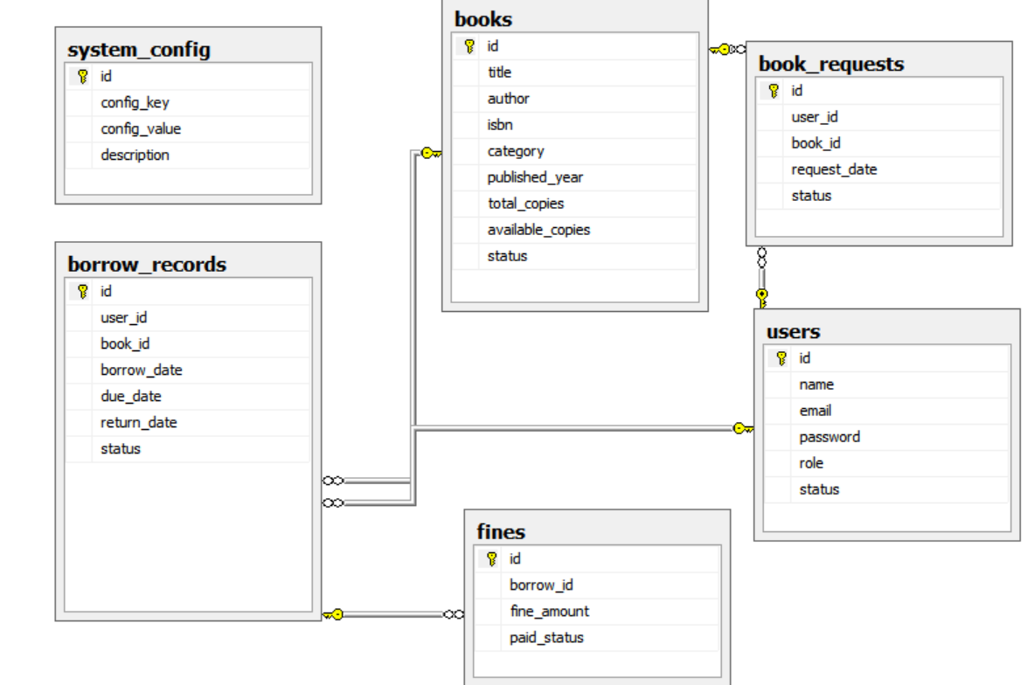

Database diagram

Rules:

- The group includes : 2-3 students

- Project evaluation will begin in the first day of week 9. Teacher will randomly call groups to present, and any group that is called but does not present will receive a score of 0.

- Each student must complete Workshop 1, Workshop 2, and the assignment. If any part is missing, the score for that component will be 0.

- Total 10/student

The End